Testing Kafka Behavior

We Will Be Doing the following Things

1. Start MS SQL Server (Checking all necessary properties i.e., Enabling CDC etc)
2. Start VMware and Connect MobaXterm
3. Console 1 – Start Zookeeper
4. Console 2,3,4 - Start 3 Brokers respectively
5. Console 5 – Create the Potential Topic That should be created by the Connector when run in the next step
6. Console 4 – Run Connector
7. Console 6,7,8 – Create broker respective Consumers

**Zookeeper**

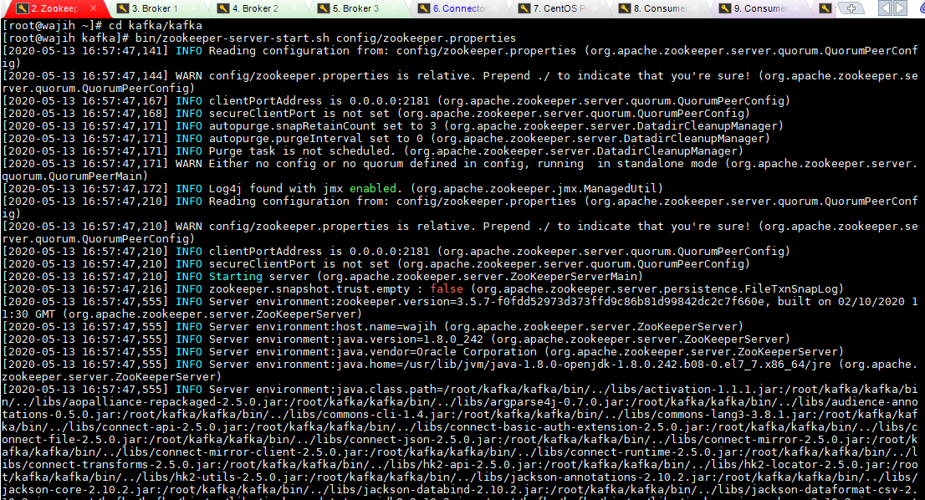

**Brokers**

When Zookeeper is running successfully, now we can run Brokers

Broker 1

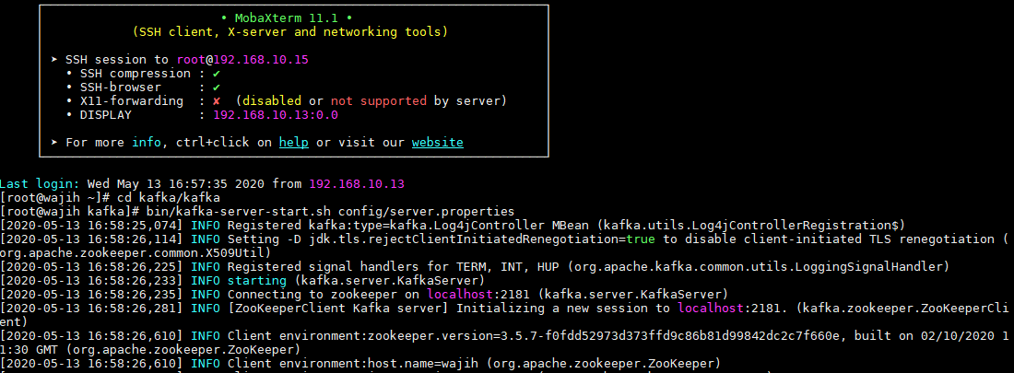

Broker 2



Broker 3

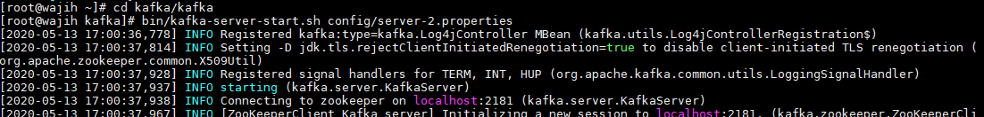

**Connector**

Since we need to connect with My SQL Server, we will create a connector as shown in the picture.

We will run this after creating Topic

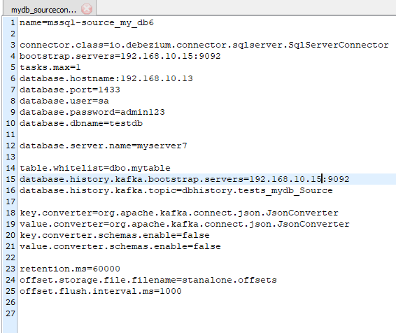

Running Connector

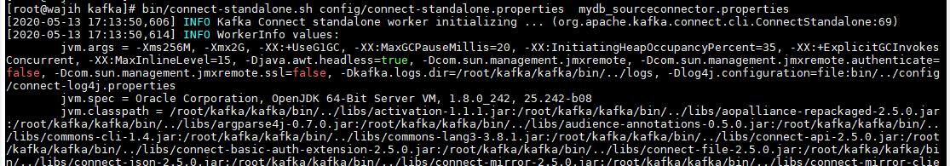

Connector Run Successfully

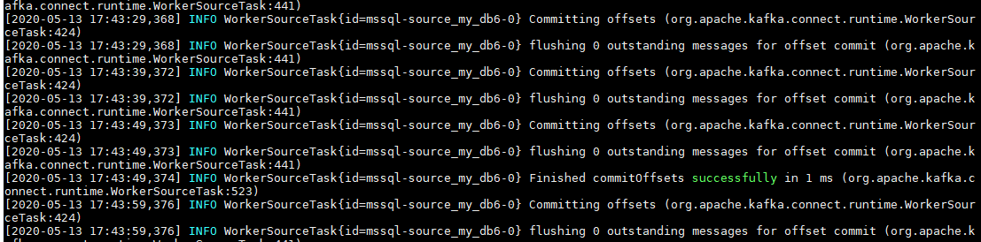

**Topic**

Now we created a topic myserver7.dbo.mytable with

* Replication factor = 1
* Partitions = 3

Topics with descriptions

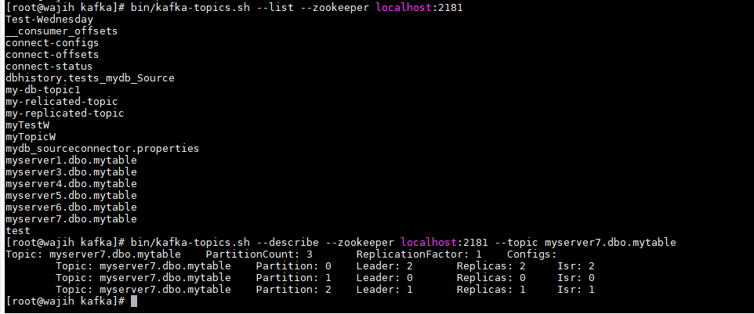

**Consumers**

To get the data that is fetched into the topic by the connector, we will run the consumer.

Since we are testing with three brokers and three consumers, we will run three consumers in three different consoles.

Initially we will get all data from topic to consumer and then we will check instantly put data.

Consumer 1 from Beginning

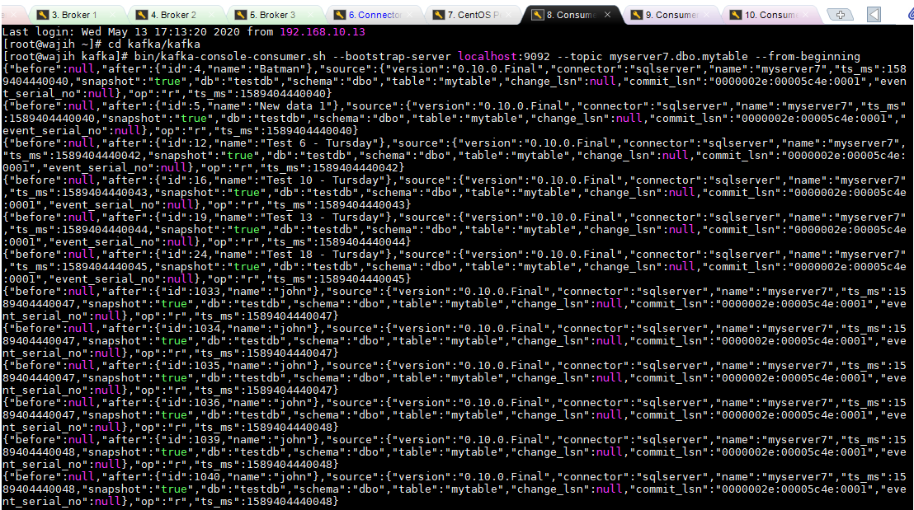

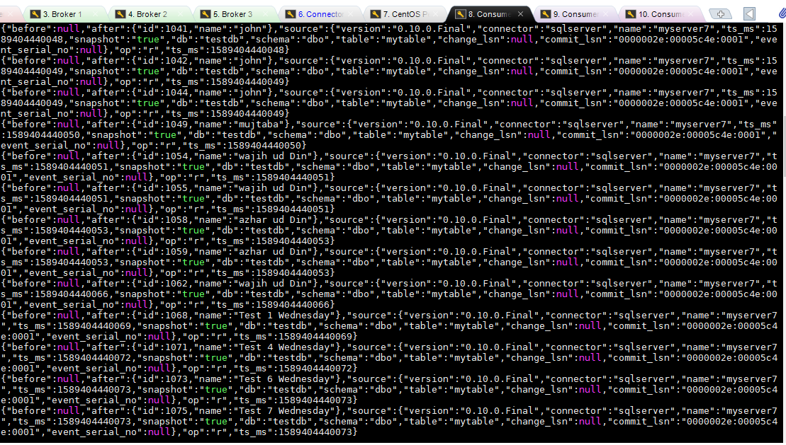

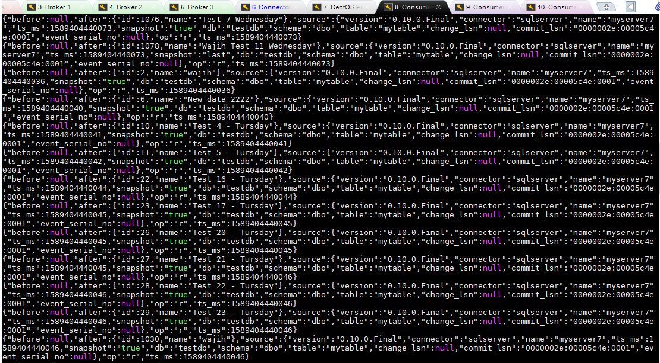

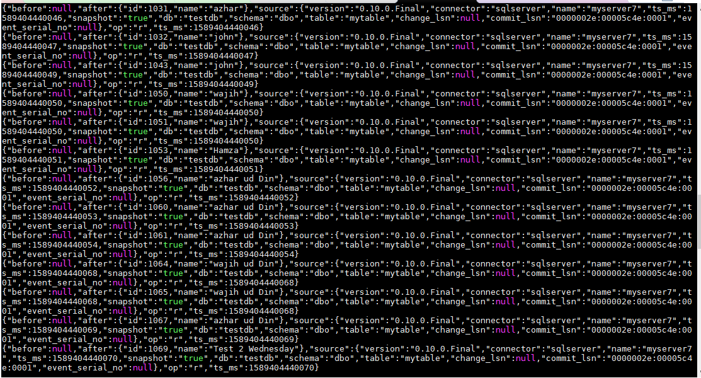

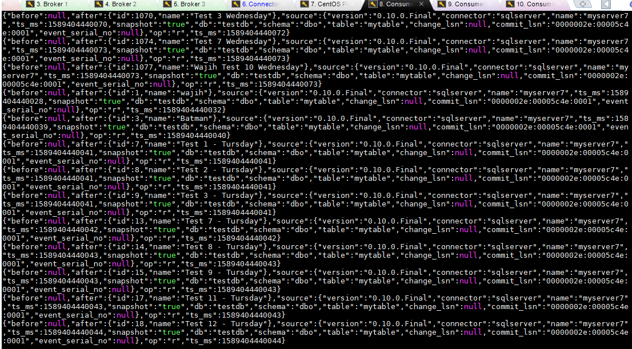

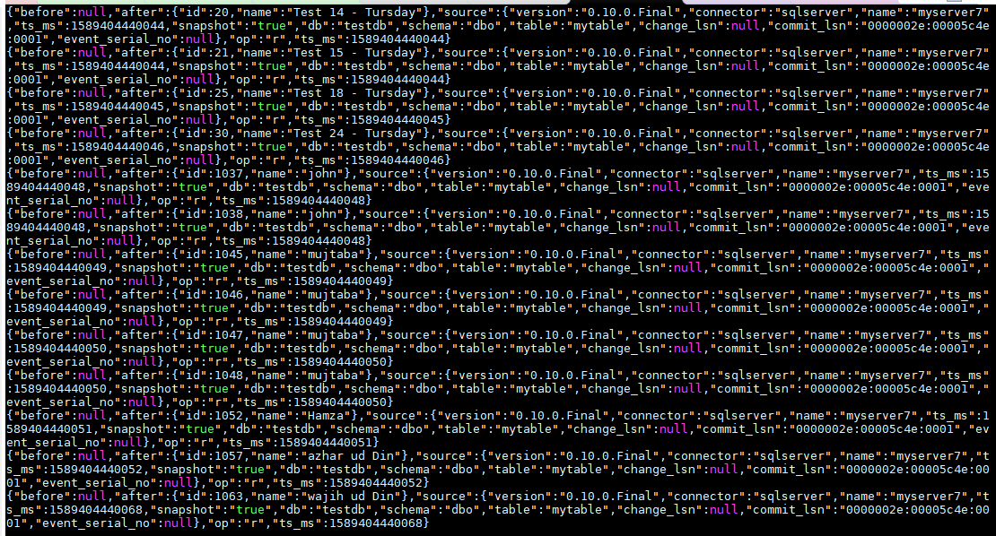



Consumer 2 from beginning

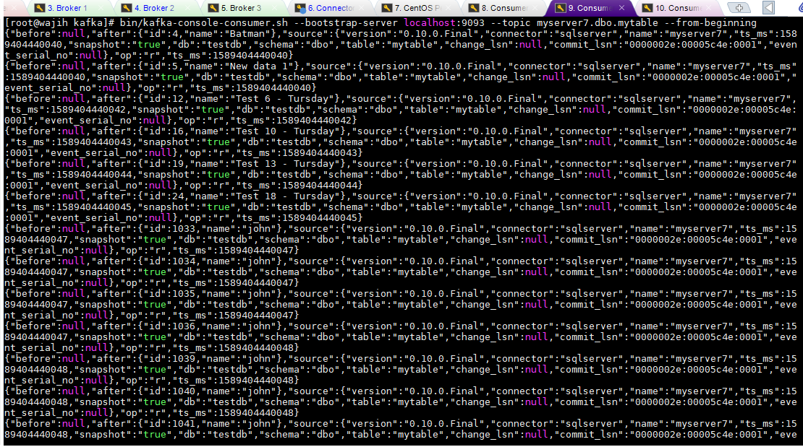

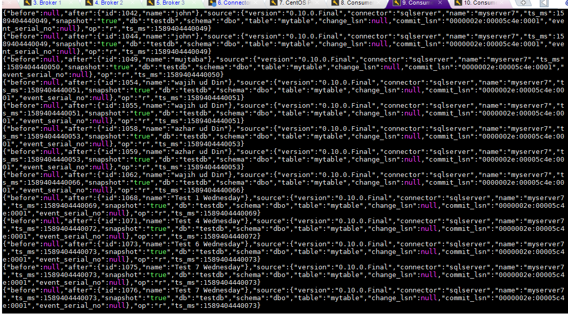

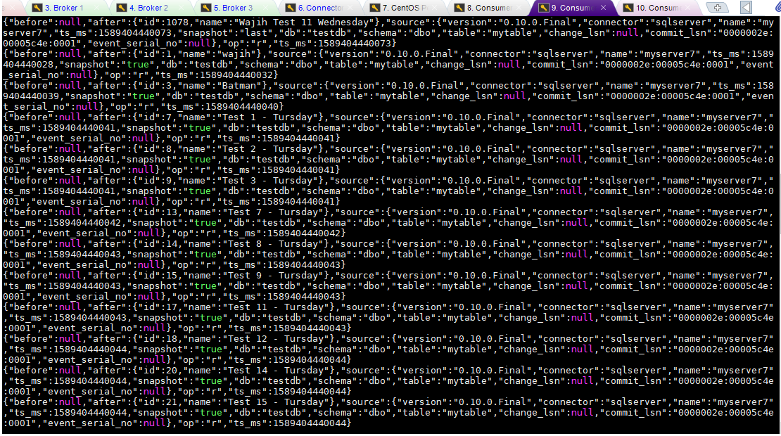

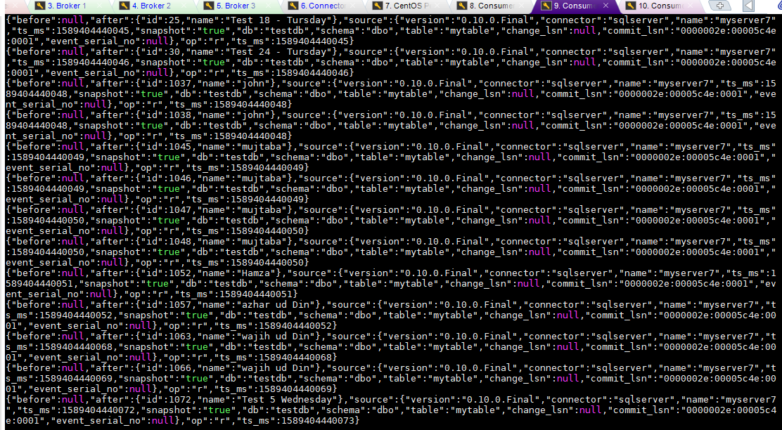

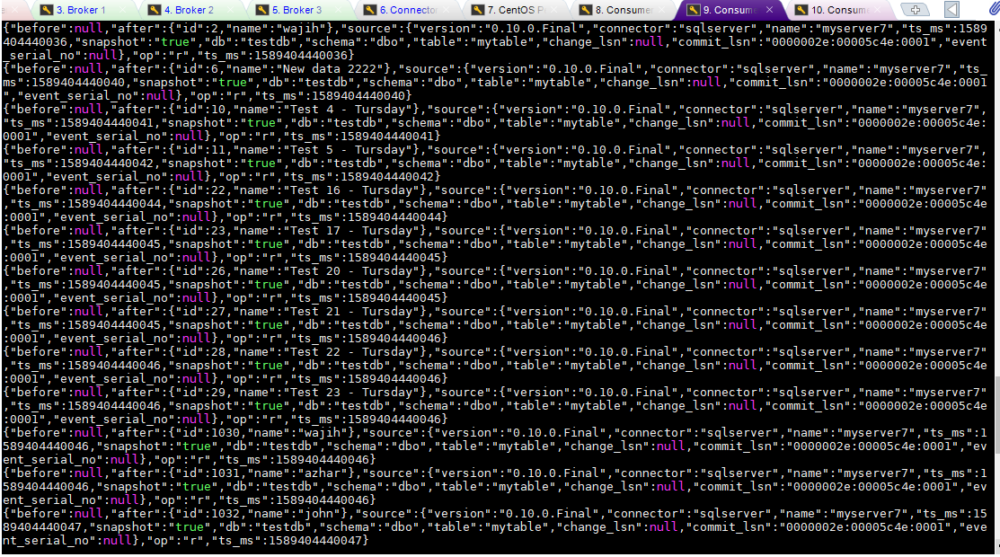

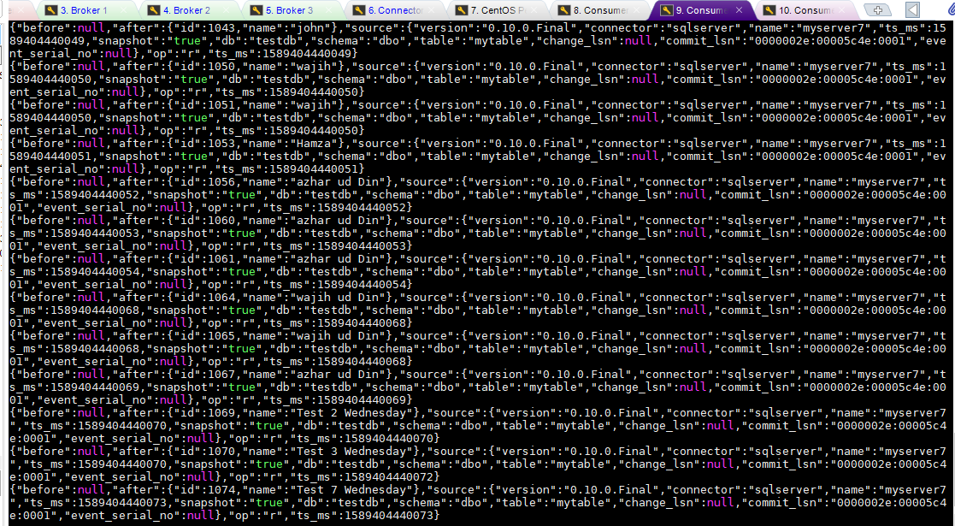



Console 3 From Beginning

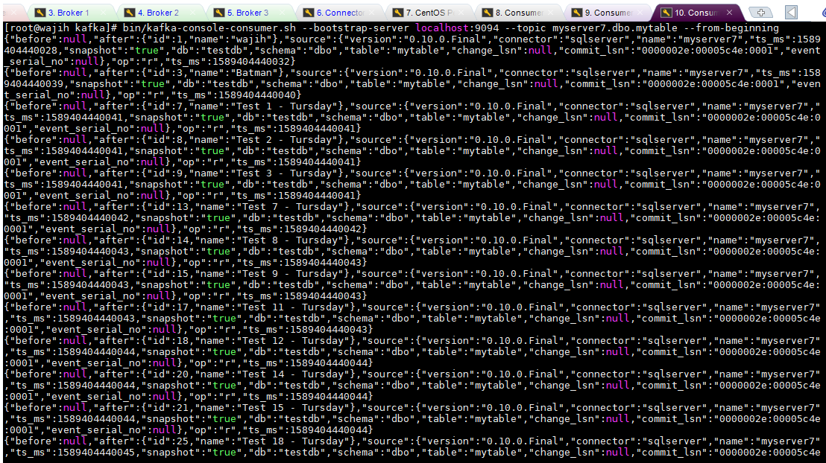

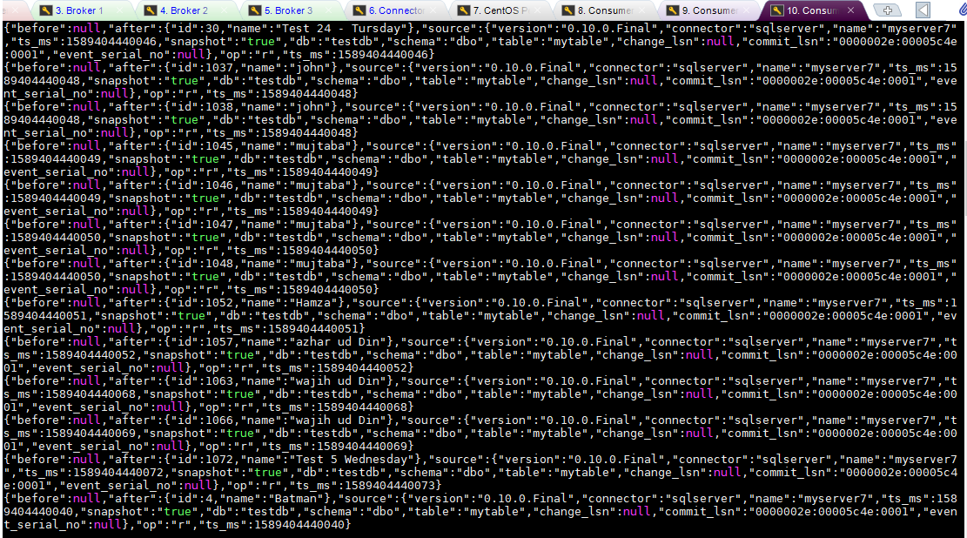

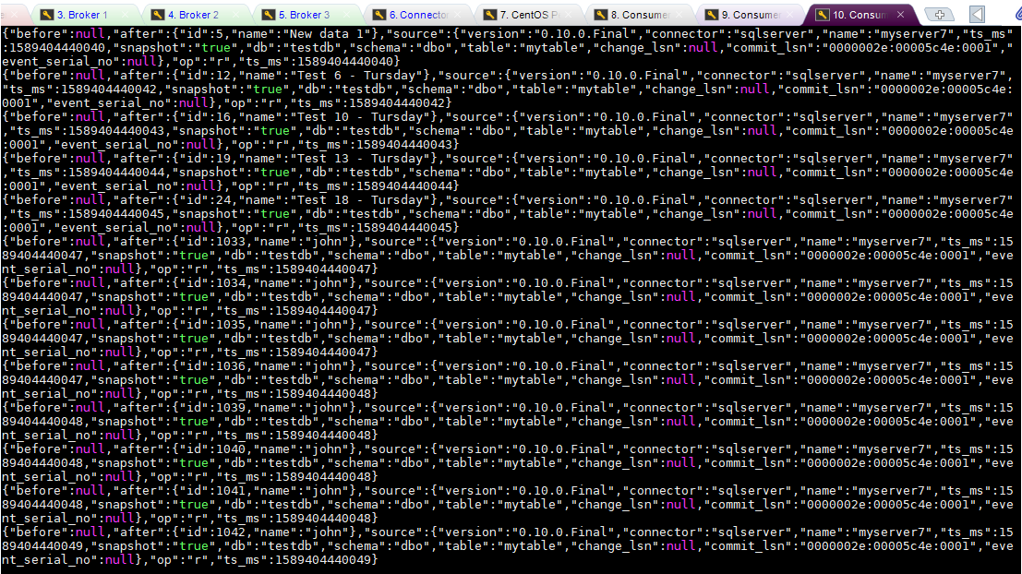

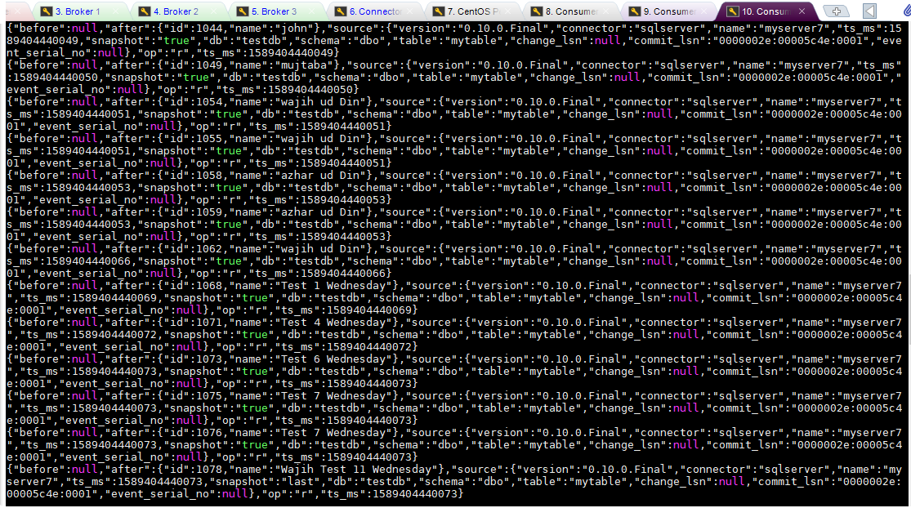

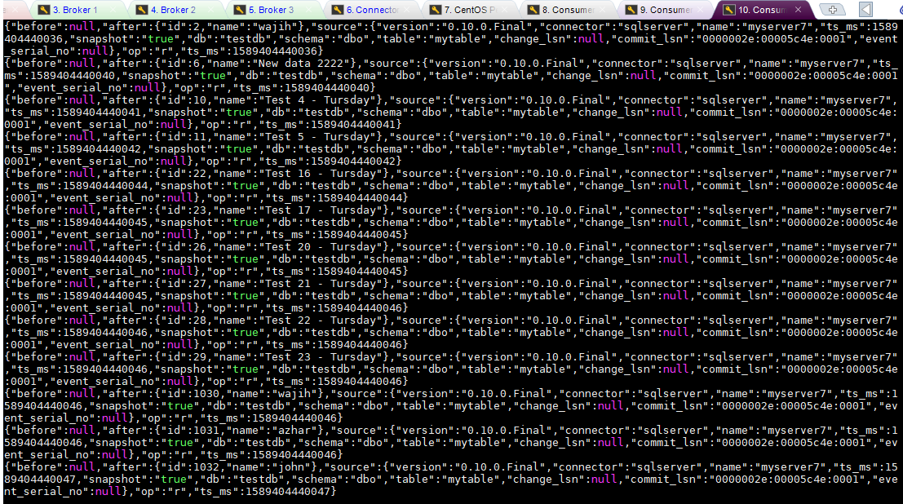

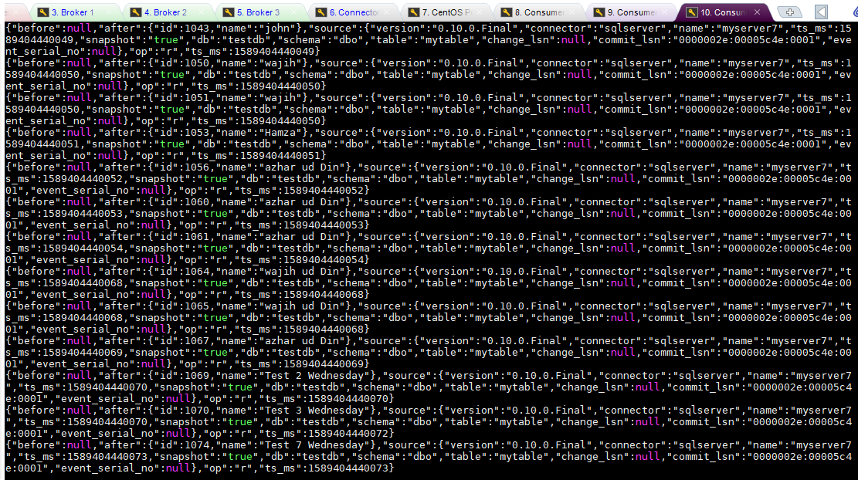



For Instant Message push

Now, all data that is already in the database has been fetched, so we will push some more data from the My Sql Server to the kafka simultaneously.

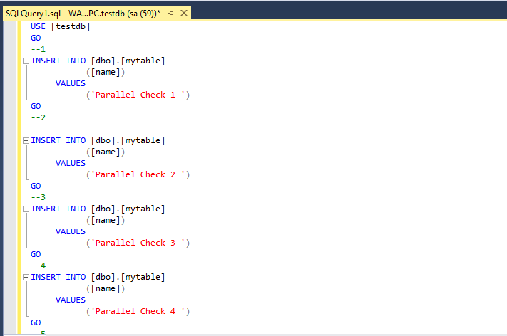

Data is like this till 7.

The SQL query sheet is run all at once and the results in kafka are as follows

Consumer 1

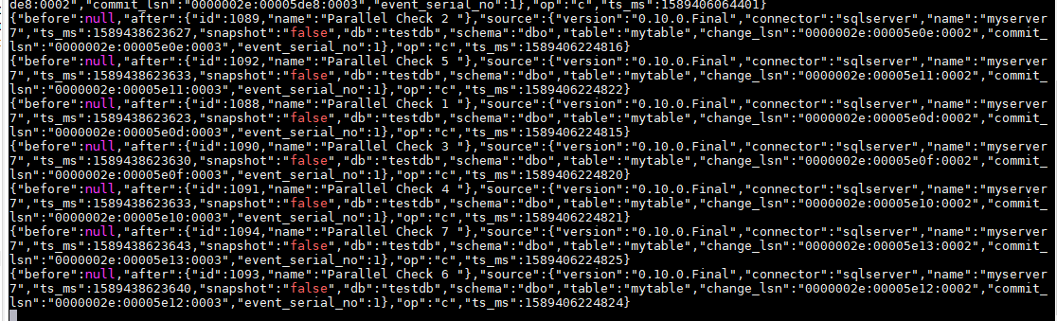

Consumer 2

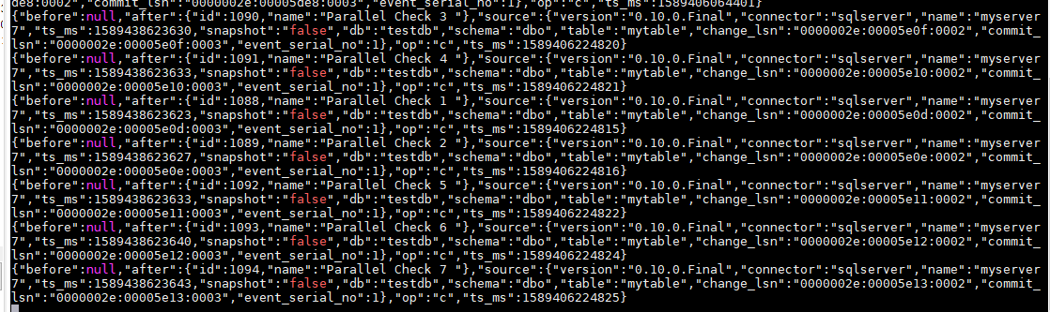

Consumer 3

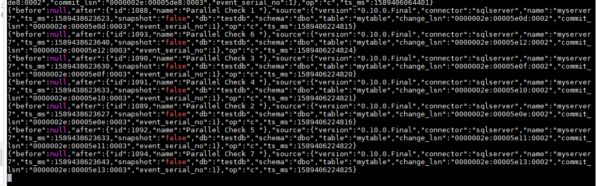

**Analyzing Outputs**

For analyzing output, we will compare the Id’s in all three of consumers.  
Lets see the ids of result of from beginning

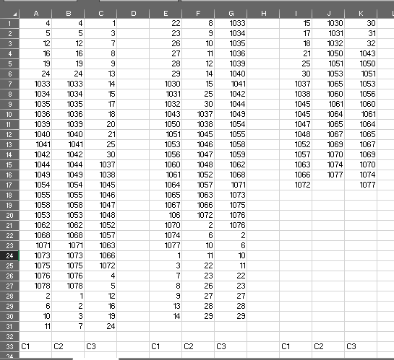

Lets see the Results of parallel data push test output ids

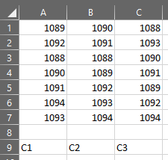

**Conclusion:**

When we compare the results, We get the following results

* No entry is missing and all data either from beginning or instant push has been received by consumers
* Data is Partitioned which is clear from the different order of data in all consumers
* Kafka is working as per theory